**Integration Guide for IoT**

1. **IAR V8.50.1 Version for Babelfish release 2.15**This release 2.15 of Babelfish is built and tested with below mentioned version of IAR 8.50.1  
     
   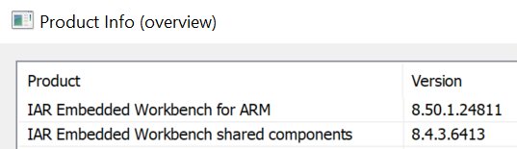
2. **Add below mentioned files to the IAR workspace.**
   1. Add following files in the Babelfish/BF/IOT folder in the IAR workspace.

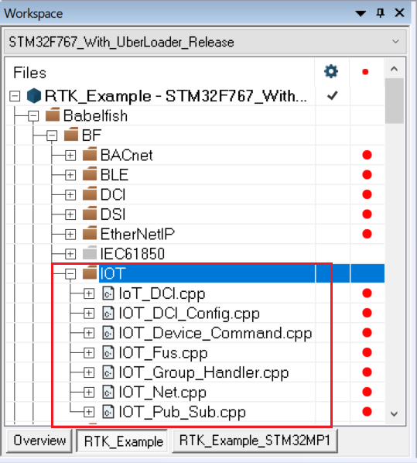

* 1. Add following files in the Babelfish/IOT folder

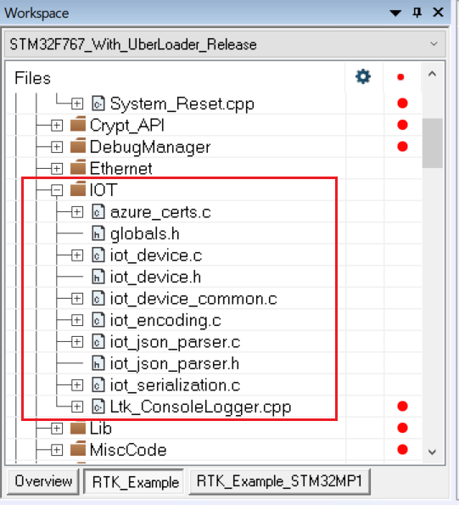

* 1. Add following folders in the Babelfish/ThirdParty folder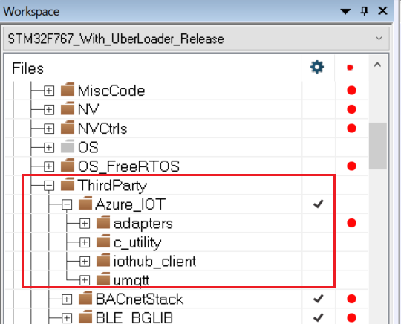
  2. Add following files in the Babelfish/ThirdParty/Azure_IOT/adapters folder

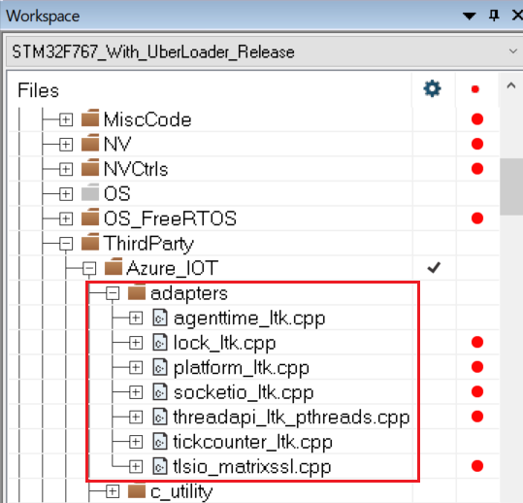

* 1. Add following files in the Babelfish/ThirdParty/Azure_IOT/c_utility folder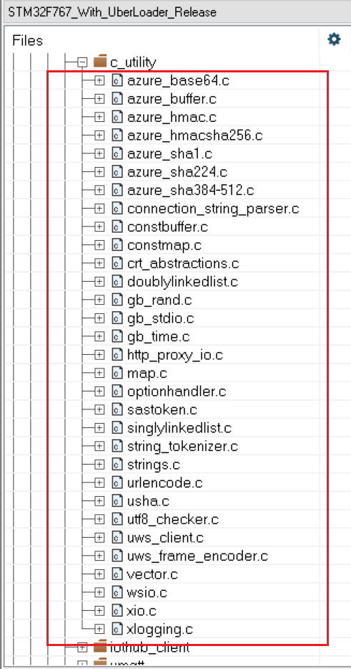
  2. Add following files in the Babelfish/ThirdParty/Azure_IOT/iothub_client folder.

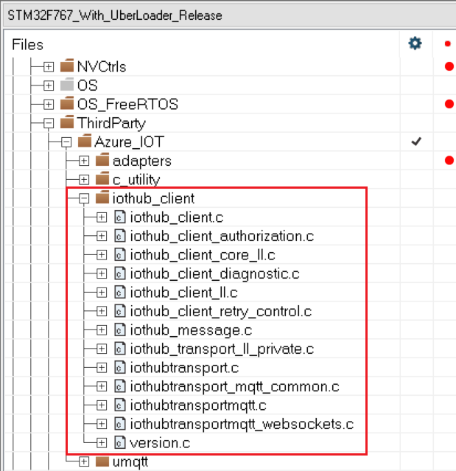

* 1. Add following files in the Babelfish/ThirdParty/Azure_IOT/umqtt folder.

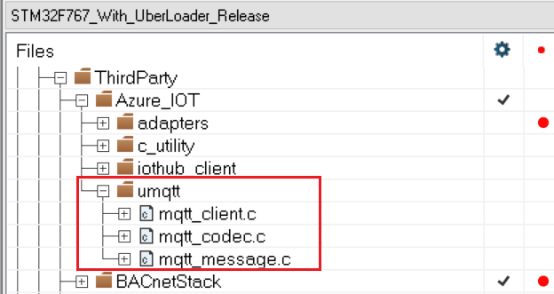

* 1. Add IOT_DCI_Data.cpp in the BFData folder.

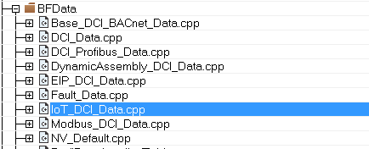

1. **Add following directories in the “preprocessor” of IAR**

$PROJ_DIR$\Babelfish\Code\BF\IOT

$PROJ_DIR$\Babelfish\Code\IOT\platform_device_sdk_v2\include $PROJ_DIR$\Babelfish\Code\ThirdParty\Azure_IOT\Azure_repo\iothub_client\inc

$PROJ_DIR$\Babelfish\Code\ThirdParty\Azure_IOT\Azure_ltk_adapters

$PROJ_DIR$\Babelfish\Code\ThirdParty\Azure_IOT\Azure_repo\c_utility\inc

$PROJ_DIR$\Babelfish\Code\ThirdParty\Azure_IOT\Azure_repo\c_utility\inc\azure_c_shared_utility

$PROJ_DIR$\Babelfish\Code\ThirdParty\Azure_IOT\Azure_repo\c_utility\pal\generic

$PROJ_DIR$\Babelfish\Code\ThirdParty\Azure_IOT\Azure_repo\umqtt\inc

$PROJ_DIR$\Babelfish\Code\ThirdParty\Azure_IOT\Azure_repo\umock_c\inc

1. **Make sure that you latest version of following files in ltk_sample_app\RTK_Example\Code\Config folder**

iot_define_config.xcl

IoT_Config.h

1. **Make sure that you have the latest version of following files in ltk_sample_app\RTK_Example\Code**

Prod_Spec_IOT.cpp

Prod_Spec_IOT.h

Add Prod_Spec_IOT.cpp file in the IAR workspace as follows:

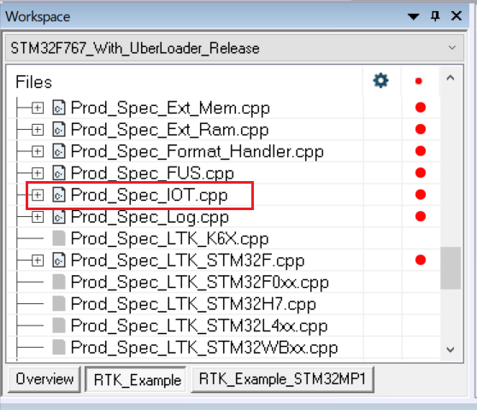

1. **Make sure that you have IOT sheet and IOT groups sheet in the RTK DCI DB Creator.xlsm workbook as follows:**

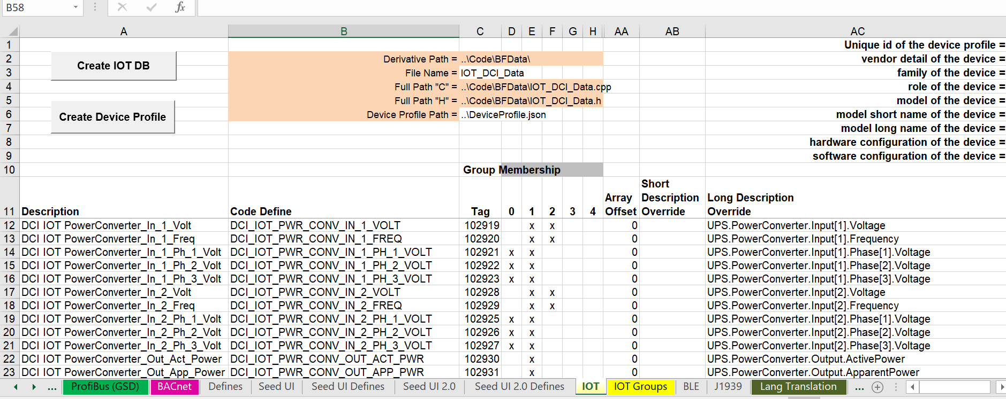

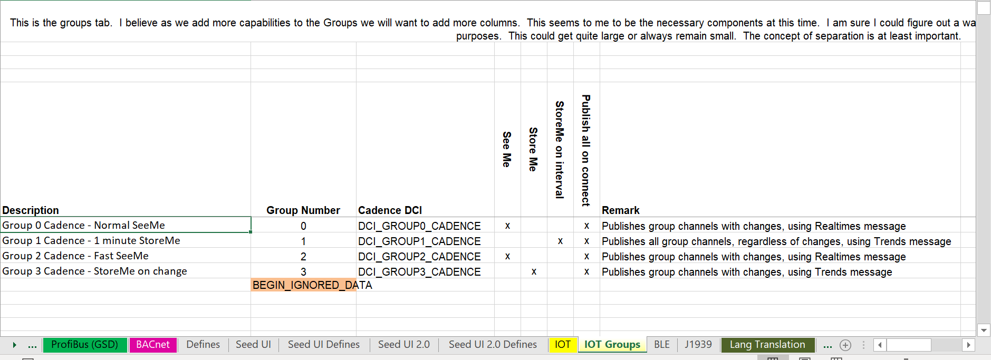

1. **Make sure that you have VBA macro code ltk_sample_app\RTK_Example\Babelfish\Tools\DCI_DB_Creator_Macro_Code\IOT_Builder.bas file that supports macros in IOT sheet**
2. **Make sure that you have the following IOT related DCIDs in the DCI Descriptor sheet:**

|  |
| --- |
| DCI_IOT_CONNECT |
| DCI_IOT_STATUS |
| DCI_IOT_PROXY_ENABLE |
| DCI_IOT_PROXY_SERVER |
| DCI_IOT_PROXY_PORT |
| DCI_IOT_PROXY_USERNAME |
| DCI_IOT_PROXY_PASSWORD |
| DCI_IOT_DEVICE_GUID |
| DCI_IOT_DEVICE_PROFILE |
| DCI_IOT_CONN_STRING |
| DCI_IOT_UPDATE_RATE |
| DCI_IOT_CADENCE_UPDATE_RATE |
| **DCI_IOT_PWR_CONV_IN_1_VOLT** |
| **DCI_IOT_PWR_CONV_IN_1_FREQ** |
| **DCI_IOT_PWR_CONV_IN_1_PH_1_VOLT** |
| **DCI_IOT_PWR_CONV_IN_1_PH_2_VOLT** |
| **DCI_IOT_PWR_CONV_IN_1_PH_3_VOLT** |
| **DCI_IOT_PWR_CONV_IN_2_VOLT** |
| **DCI_IOT_PWR_CONV_IN_2_FREQ** |
| **DCI_IOT_PWR_CONV_IN_2_PH_1_VOLT** |
| **DCI_IOT_PWR_CONV_IN_2_PH_2_VOLT** |
| **DCI_IOT_PWR_CONV_IN_2_PH_3_VOLT** |
| **DCI_IOT_PWR_CONV_OUT_ACT_PWR** |
| **DCI_IOT_PWR_CONV_OUT_APP_PWR** |
| **DCI_IOT_PWR_CONV_OUT_CURRENT** |
| **DCI_IOT_PWR_CONV_OUT_EFF** |
| **DCI_IOT_PWR_CONV_OUT_FREQ** |
| **DCI_IOT_PWR_CONV_OUT_VOLT** |
| **DCI_IOT_PWR_CONV_OUT_PH_1_PER_LOAD** |
| **DCI_IOT_PWR_CONV_OUT_PH_2_PER_LOAD** |
| **DCI_IOT_PWR_CONV_OUT_PH_3_PER_LOAD** |
| **DCI_IOT_PWR_CONV_TYPE** |
| **DCI_IOT_PWR_SUM_I_PART_NUM** |
| **DCI_IOT_PWR_SUM_VOLT** |
| **DCI_IOT_BATSYS_BAT_POL_1_VOLT** |
| **DCI_IOT_PWR_SUM_TEMP** |
| **DCI_IOT_PWR_SUM_RUNTIME_TO_EMP** |
| **DCI_IOT_PWR_SUM_REM_CAP** |
| **DCI_IOT_PWR_SUM_PER_LOAD** |
| **DCI_IOT_PWR_SUM_MODE** |
| **DCI_IOT_PWR_SUM_ALM_CODE** |
| **DCI_IOT_PWR_CONV_IN_2_SWOFF_CON** |
| **DCI_IOT_PWR_CONV_IN_2_SWON_CON** |
| **DCI_IOT_OUTLSYS_OUTL_1_STAT** |
| **DCI_IOT_OUTLSYS_OUTL_2_STAT** |
| **DCI_IOT_OUTLSYS_OUTL_3_STAT** |
| **DCI_IOT_BATSYS_BAT_TEST** |
| **DCI_IOT_BATSYS_BAT_TEST_COM** |
| **DCI_IOT_BATSYS_BAT_ADTST_TST_W_DUR** |
| **DCI_IOT_BATSYS_BAT_ADTST_TST_W_LVL** |
| DCI_GROUP0_CADENCE |
| DCI_GROUP1_CADENCE |
| DCI_GROUP2_CADENCE |
| DCI_GROUP3_CADENCE |
| DCI_IOT_CONN_STAT_REASON |

In the above mentioned DCIDs, the ones that are highlighted in bold are the channels specific to the default innova profile (These channels belong to default device profile identified by c234f396-bfbf-4ea3-aecb-cd4842693132 ). These channels can be found in the IOT sheet of DCI DB Creator workbook. If adopter have their own device profile then they can modify the IOT sheet and DCI Descriptors sheet accordingly. Refer this document on how to add/delete channels - <https://bitbucket-prod.tcc.etn.com/projects/LTK/repos/babelfish/browse/Code/IOT/documents/iot_enable.md>

1. **Do additional product specific changes, if any, and then compile the code.**
2. **To enable IOT, refer** [PX Green IOT Setup Guide](https://confluence-prod.tcc.etn.com/display/LTK/PX+Green+IOT+Setup+Guide)
3. **Additional documents can be found here -** <https://bitbucket-prod.tcc.etn.com/projects/LTK/repos/babelfish/browse/Code/IOT/documents>